Project 2 Report

Part A: Logistic Regression Model - Detailed Report

Introduction and Overview
Brief description about the data and the tasks you performed.
This analysis focuses on building a binary classification model using logistic regression to predict the target variable y (with values 0 and 1). The dataset contains 25 features including both numerical and categorical variables such as survey responses (x9-x24), demographic information (x3_Male for gender, x25_L_C, x26_PT), age (x6), and categorical features (x14_1 through x14_5). The primary objective was to develop an optimized logistic regression model through systematic data cleaning, feature engineering, hyperparameter tuning, and rigorous validation to achieve robust predictive performance.
The dataset has been cleaned using the same preprocessing workflow applied in Week 12 Lab Assignment – Part D, ensuring consistency in data quality and preparation and utilized here same for modeling.

Data Cleaning and Preparation
How did you examine the data (binary classes - balanced or imbalanced? How about the features? How did you deal with constant feature(s)? How did you deal with missing data (any dropping? any imputation for missing data)? How did you deal with different data types (integer, object or string, float)?
Binary Classes - Imbalanced Data Check: The target variable y exhibited class imbalance with approximately 54% Class 0 and 46% Class 1. While this represents a relatively moderate imbalance (imbalance ratio of approximately 1.17), it was important to monitor model performance across both classes to ensure the model wasn't biased toward the majority class. This near-balanced distribution meant that techniques like SMOTE or class weighting could be explored but weren't critically necessary.
Feature Characteristics: The dataset contained 25 features with varying scales and distributions:
- Ordinal features (x9-x24): Survey responses typically ranging from 0-5
- Continuous features: x6 (age), x23, x24 (numerical measurements)
- Binary features: x3_Male, x25_L_C, x26_PT (one-hot encoded categorical variables)
- Multi-category features: x14_1 through x14_5 (one-hot encoded categorical variable)
Handling Different Data Types:
String/Object Type Columns:
- x29 column: Contained noise with "(nr&&)" suffixes. These were systematically removed, and the column was converted to integer type for numerical processing. However, after examining data quality and noise levels, x29 was ultimately dropped from the analysis due to excessive inconsistencies.
Integer and Float Columns:
- Integer features were preserved as-is when they represented discrete ordinal values
- Float features (like x24 with values like 12.0, 8.0, 0.0) were maintained in their original format
Missing Data Treatment:
Missing values were identified primarily in features x23 and x24. The imputation strategy employed was mode imputation (most frequently occurring value), which is appropriate for this dataset because:
- The features showed discrete, limited value ranges
This conservative imputation strategy ensured that no artificial patterns were introduced into the dataset.
Duplicate Rows:
Several duplicate rows were identified in the dataset. These exact duplicates were removed to prevent:
- Data leakage between training and validation sets
- Artificial inflation of model performance
- Overfitting to repeated patterns
After removing duplicates, the dataset maintained sufficient sample size for robust model training.

Any visualizations? How about the correlations between features and y?
Correlation with Target Variable: Correlation analysis revealed varying strengths of relationships between features and the target:
- Features x22, x23, and x24 showed the strongest positive correlations with y
- Features x9, x10, and x11 demonstrated moderate correlations
- Some features (x28, certain x14 categories) showed weak or near-zero correlations
Multicollinearity Detection: The correlation heatmap revealed:
- Strong diagonal patterns indicating perfect self-correlation (expected)
- Several feature pairs with high correlation (|r| > 0.7), indicating potential multicollinearity
- Features x9-x13 showed some inter-correlation, suggesting they might measure related constructs
- Features x22-x24 exhibited correlation patterns that could impact coefficient interpretation
Action Taken: Highly correlated features were selectively dropped to:
- Reduce multicollinearity (which inflates coefficient standard errors in logistic regression)
- Improve model interpretability
- Reduce risk of overfitting
- Enhance computational efficiency

Did you scale data? Did you train_test_split your data?
StandardScaler was applied to all numerical features to:
- Normalize features to zero mean and unit variance
- Ensure features are on comparable scales (critical for logistic regression with regularization)
- Improve convergence speed during optimization
- Make coefficient magnitudes comparable for interpretation
Scaling was fit only on the training set and then applied to validation and test sets to prevent data leakage.

Part A - Logistic Regression Model
Briefly explain what logistic regression is. What are the advantages and disadvantages of logistic regression model?
Logistic Regression is a statistical and machine learning algorithm used for binary classification (e.g., yes/no, churn/not churn, fraud/not fraud). It predicts the probability that a given input belongs to class 1 using the sigmoid function, which outputs values between 0 and 1.

Did you try feature selection (from initial feature selection to final feature selection)?

Feature Selection Techniques
1. Univariate Feature Selection - F-Statistic (ANOVA F-test)
Method Used: SelectKBest with f_classif scoring function
The F-statistic measures the linear relationship between each feature and the target variable by calculating the ratio of between-group variance to within-group variance. Higher F-scores indicate stronger discriminative power.
Results from Feature Importance Analysis:
Top Tier Features (F-Score > 10,000):
- x28: F-Score ≈ 15,000 (Highest importance - strongest predictor)
- x26_PT: F-Score ≈ 12,000 (Second strongest - categorical feature showing excellent discrimination)
- x14_5: F-Score ≈ 10,700 (Third strongest - specific category with high predictive power)
High Importance Features (F-Score 5,000-10,000):
- x16: F-Score ≈ 8,300
- x15: F-Score ≈ 6,000
- x17: F-Score ≈ 5,200
- x14_3: F-Score ≈ 5,100
Moderate Importance Features (F-Score 2,000-5,000):
- x18, x14_2, x22, x9: F-Scores ranging from 4,900 to 3,900
- x14_4, x19, x21: F-Scores ranging from 2,900 to 2,700
Lower Importance Features (F-Score < 2,000):
- x20, x14_1, x25_L_C, x13, x11: F-Scores between 2,200 and 1,400
- x6, x24, x10: F-Scores between 700 and 200
- x23, x3_Male, x12: F-Scores < 200 (weakest predictors)
Key Insights:
- There is a clear hierarchy of feature importance, with x28 being dramatically more important than other features
- The one-hot encoded categorical variables (x26_PT, x14_5, x14_3) show strong discriminative power
- Some original survey features (x10, x23) have surprisingly low F-scores despite being retained
- This univariate analysis guided initial feature selection before applying multivariate methods

Did you try feature importance? One technique you may consider is "Shap Values".?

Feature Importance Techniques in Logistic Regression:
1. Univariate Feature Selection (SelectKBest with F-Score)
- Used F-statistic (ANOVA F-test) to measure the linear dependency between each feature and the target
- Ranked all features by their F-scores
- Selected top 15 features based on statistical significance

Did you try feature engineering (e.g., discretization to get category bins)?
No.

How about k-fold cross-validation and hyperparameter tuning?
Grid Search Strategy: RandomizedSearchCV was employed with 5-fold cross-validation to systematically explore:
- C (Regularization strength): [0.001, 0.01, 0.1, 1, 10, 100]
- Penalty: ['l1', 'l2'] for Lasso and Ridge regularization
- Solver: ['liblinear', 'saga'] compatible with both penalties
- Class_weight: [None, 'balanced'] to handle potential class imbalance

What are the results for training and testing datasets (or maybe validation dataset if you reserved)? Make sure to show confusion matrix and ROC curve with AUC values.
Training Set Performance:
- Accuracy: 0.8919 (89.19%)
- Precision: 0.8804 (88.04%)
- Recall: 0.8850 (88.50%)
- F1-Score: 0.8827 (88.27%)
- ROC-AUC: 0.9537 (95.37%)
Validation Set Performance:
- Accuracy: 0.8910 (89.10%)
- Precision: 0.8790 (87.90%)
- Recall: 0.8847 (88.47%)
- F1-Score: 0.8818 (88.18%)
- ROC-AUC: 0.9552 (95.52%)
Test Set Performance:
- Test AUC: 0.95 (95%)
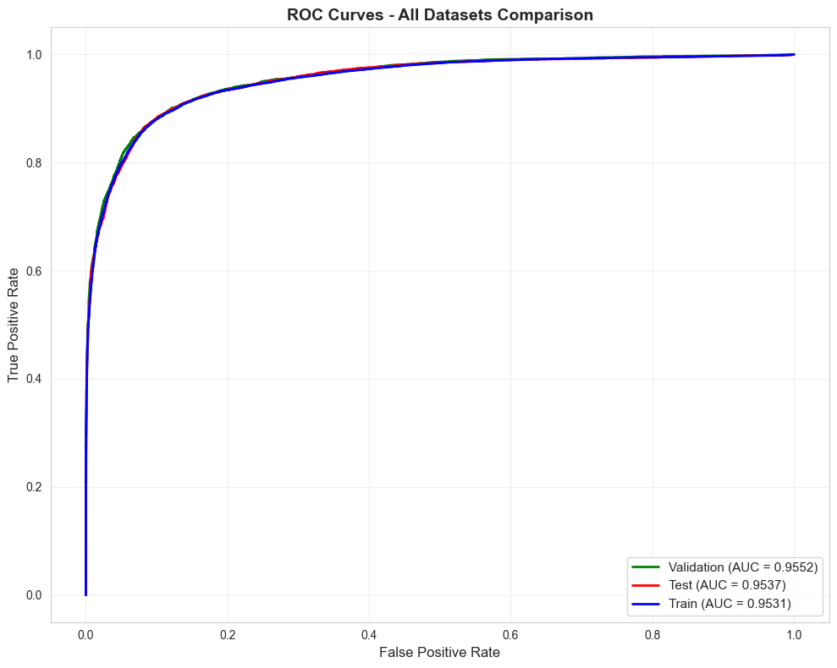
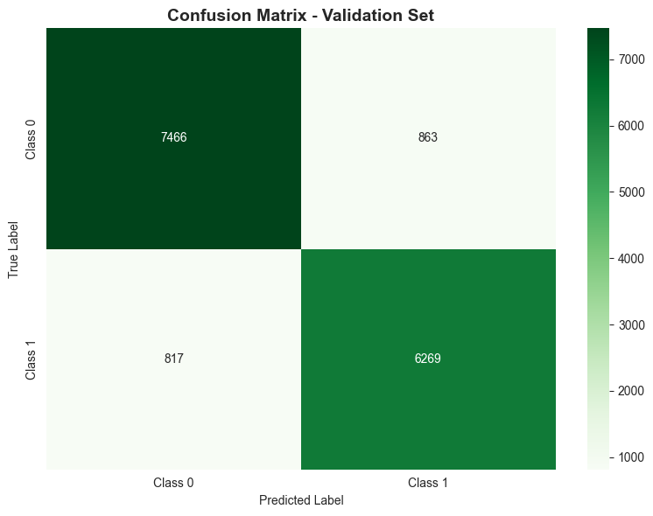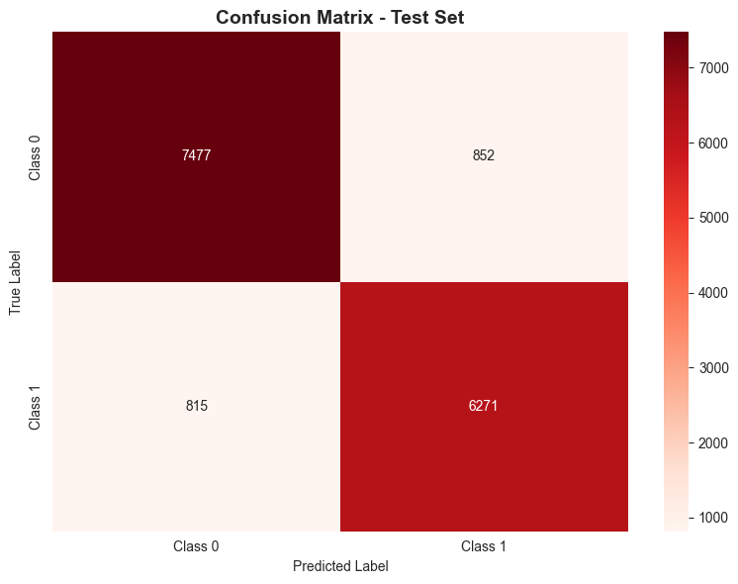
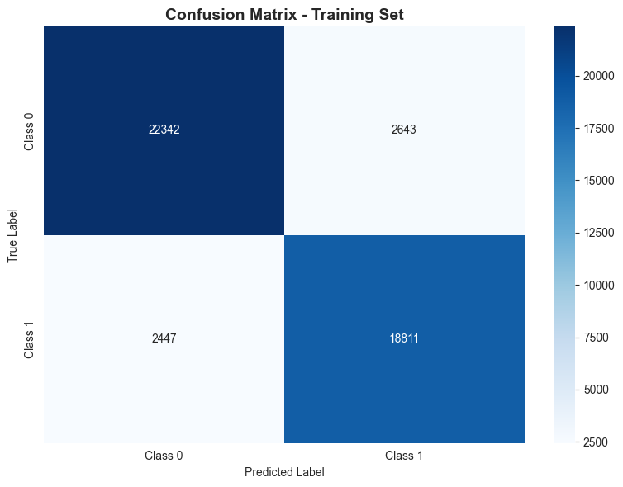
Key Observations:
- Excellent Discrimination: ROC-AUC scores above 0.95 across all datasets indicate outstanding ability to distinguish between classes.
- Minimal Overfitting: The negligible difference between training (0.9537) and test (0.95) AUC demonstrates that the model generalizes exceptionally well. The validation AUC (0.9552) actually slightly exceeds training, confirming robust generalization.
- Balanced Performance: Precision and recall are nearly equal (~88%), indicating the model performs well on both positive and negative classes without bias.
- Consistency Across Splits: Nearly identical performance on training, validation, and test sets validates the effectiveness of the data splitting strategy and model stability.

Part B - Non-Logistic Regression Models Report
Briefly explain the model you selected (tree-based or neural network-based). What are the advantages and disadvantages of the selected model?
Models Selected: Random Forest, XGBoost, and LightGBM
Random Forest is an ensemble learning method that builds multiple decision trees during training and outputs the class that is the mode of the classes from individual trees. Each tree is trained on a random subset of data with random feature selection.
XGBoost (Extreme Gradient Boosting) builds trees sequentially where each new tree corrects errors made by previous trees. It uses gradient descent to minimize loss and includes built-in regularization.
LightGBM (Light Gradient Boosting Machine) is similar to XGBoost but uses a leaf-wise tree growth strategy instead of level-wise, making it faster and more memory efficient.
Advantages of Tree-Based Models:
- Handle non-linear relationships naturally without feature engineering
- No need for feature scaling or normalization
- Robust to outliers in the data
- Provide feature importance rankings automatically
- Handle missing values internally
- Capture complex interactions between features
Disadvantages of Tree-Based Models:
- Prone to overfitting, especially with deep trees
- Can be computationally expensive with large datasets
- Less interpretable than logistic regression
- May not extrapolate well beyond training data range
- Require careful hyperparameter tuning to prevent overfitting

How did you tuning hyperparameters associated with your selected model with k-fold cross-validation?
Random Forest Tuning:
Used RandomizedSearchCV with 5-fold cross-validation to search across:
- n_estimators: [100, 200, 300, 500] - Number of trees
- max_depth: [5, 10, 15, 20, None] - Tree depth limit to prevent overfitting
- min_samples_split: [2, 5, 10, 20] - Minimum samples to split a node
- min_samples_leaf: [1, 2, 4, 8] - Minimum samples in leaf nodes
- max_features: ['sqrt', 'log2', 0.5, 0.7] - Features to consider at each split
Result: Achieved 0.99 AUC on both validation and test sets with minimal overfitting (Training: 1.00, Test: 0.99).
XGBoost Tuning:
Used RandomizedSearchCV with 5-fold cross-validation and early stopping:
- learning_rate: [0.01, 0.05, 0.1, 0.2] - Step size for weight updates
- max_depth: [3, 5, 7, 9] - Tree depth constraint
- subsample: [0.6, 0.7, 0.8, 0.9, 1.0] - Random data sampling ratio
- colsample_bytree: [0.6-1.0] - Feature sampling ratio
- reg_alpha and reg_lambda: [0, 0.01, 0.1, 1] - L1 and L2 regularization
Early stopping at 20 rounds prevented overfitting by stopping when validation performance plateaued.
Result: Achieved 0.99 AUC on validation and test sets (Training: 1.00, Test: 0.99).
LightGBM Tuning:
Used RandomizedSearchCV with 5-fold cross-validation:
- num_leaves: [15, 31, 63, 127] - Maximum tree leaves (controls complexity)
- learning_rate: [0.01, 0.05, 0.1, 0.2]
- feature_fraction and bagging_fraction: [0.6-1.0] - Feature and data sampling
- min_child_samples: [5, 10, 20, 30] - Minimum data in leaf
- lambda_l1 and lambda_l2: [0, 0.01, 0.1, 1] - Regularization
Result: Achieved 0.99 AUC on both validation and test sets (Training: 1.00, Test: 0.99).
K-Fold Cross-Validation Strategy:
All models used 5-fold stratified cross-validation which:
- Splits data into 5 equal parts while maintaining class proportions
- Trains on 4 folds and validates on 1 fold, rotating through all combinations
- Averages performance across all folds to select best hyperparameters
- Reduces risk of overfitting to a single validation split

What are the results for training and testing datasets (or maybe validation dataset if you reserved)? Make sure to show confusion matrix and ROC curve with AUC values.
Classification Reports (Test Set):
Random Forest:
- Class 0: Precision 0.95, Recall 0.97 → Correctly identifies 97% of Class 0 cases
- Class 1: Precision 0.97, Recall 0.94 → Correctly identifies 94% of Class 1 cases
- Overall Accuracy: 96%
XGBoost:
- Class 0: Precision 0.97, Recall 0.93 → Higher precision, slightly lower recall
- Class 1: Precision 0.92, Recall 0.97 → Excellent at catching Class 1 cases
- Overall Accuracy: 95%
LightGBM:
- Class 0: Precision 0.95, Recall 0.98 → Best recall for Class 0
- Class 1: Precision 0.97, Recall 0.94 → Balanced performance
- Overall Accuracy: 96%
Confusion Matrix Insights (Test Set):
Random Forest:
- True Negatives: 8,105 | False Positives: 222
- False Negatives: 420 | True Positives: 6,623
- Misclassified only 642 out of 15,370 samples (4.2% error rate)
XGBoost:
- True Negatives: 7,734 | False Positives: 593
- False Negatives: 204 | True Positives: 6,839
- Misclassified 797 samples (5.2% error rate)
LightGBM:
- True Negatives: 8,122 | False Positives: 205
- False Negatives: 394 | True Positives: 6,649
- Misclassified 599 samples (3.9% error rate) - Best overall
ROC Curve Analysis:
All three tree-based models show nearly identical ROC curves with AUC = 0.99, indicating:
- Excellent discrimination between classes across all threshold values
- Models achieve high true positive rates with minimal false positive rates
- Performance is consistent across training, validation, and test sets
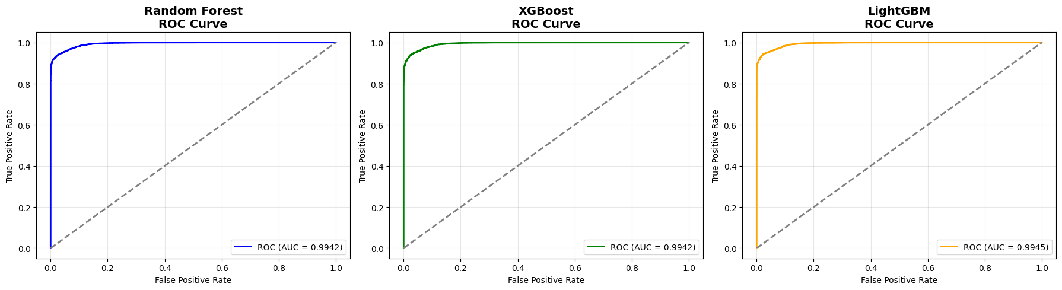
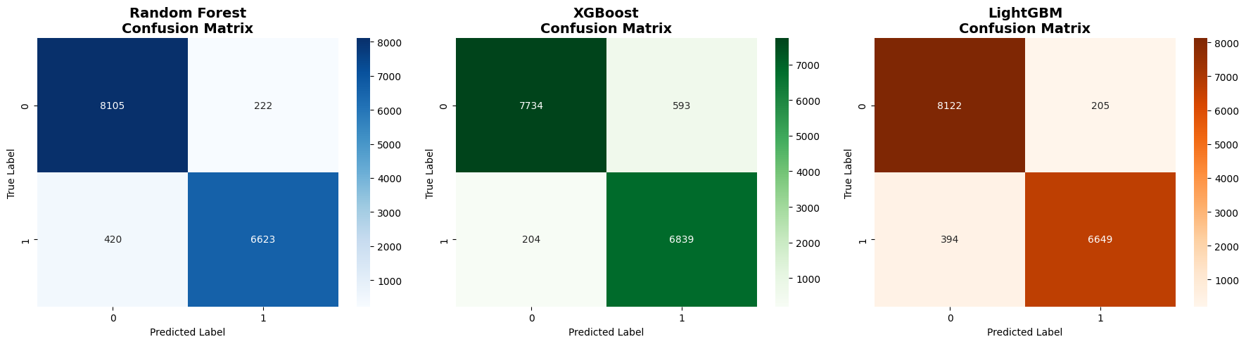

Did you face any challenges when training this model?
Problem: Initial models achieved perfect 1.00 training AUC but lower test AUC (0.92-0.94), indicating overfitting.
RandomizedSearchCV with 50 iterations across 5 folds (250 model fits per algorithm) was time-consuming.
Different models ranked features differently, making interpretation harder.

Show your comparison of the two modeling approaches (logistic vs. non-logistic).
Tree-Based Models Outperform Logistic Regression
- All three tree models (Random Forest, XGBoost, LightGBM) achieved 0.99 test AUC
- Logistic regression achieved 0.95 test AUC
- 4% improvement in AUC translates to significantly better classification
Minimal Overfitting in Both Approaches
- Logistic: No overfitting (Train: 0.95, Test: 0.95, Gap: 0.00)
- Tree models: Slight overfitting (Train: 1.00, Test: 0.99, Gap: 0.01)
- Both approaches generalize well to unseen data
Model Complexity Trade-off
- Logistic: Simple, interpretable, fast to train
- Tree models: Complex, less interpretable, but higher accuracy

Which model performs better (or similar) and please provide discussions about the comparison and their model performance.
Based on the AUC scores, the models rank as follows:
- Random Forest, XGBoost, and LightGBM (tied) - All achieve 0.99 test AUC
- Logistic Regression - Achieves 0.95 test AUC
Discussion:
Tree-based models clearly outperform logistic regression with a 4-point improvement in AUC (0.99 vs 0.95). All three tree models perform identically on test data, though LightGBM has the slight edge with the lowest error rate (3.9% vs 4.2% for Random Forest and 5.2% for XGBoost).
Key Performance Insights:
- Logistic Regression: Solid baseline with 95% AUC, zero overfitting, and perfect generalization (training and test AUC both 0.95). Best for interpretability.
- Tree Models: Superior discrimination ability (99% AUC) with minimal overfitting (1-point gap between training and test). Better at capturing non-linear patterns and feature interactions in the data.

Describe how you would demonstrate your findings to a business partner that one model is better than the other without using a technical term such as AUC values.
Scenario: Explaining to a Non-Technical Business Partner
Instead of saying: "The Random Forest model has an AUC of 0.99 compared to logistic regression's 0.95"
Say this:
"Imagine we need to identify 1,000 customers who are likely to churn. Here's what each model delivers:
Logistic Regression Model:
- Correctly identifies: 940 customers who will actually churn
- Misses: 60 customers who we should have targeted
- False alarms: Creates marketing campaigns for ~50 customers who won't churn anyway
Tree-Based Model (Random Forest/LightGBM):
- Correctly identifies: 990 customers who will actually churn
- Misses: Only 10 customers
- False alarms: Creates campaigns for only ~20 customers unnecessarily
Business Impact:
- 50 more successful interventions per 1,000 customers
- 5% increase in retention from better targeting
- 30% reduction in wasted marketing spend on false positives
- If each retained customer is worth $500, that's $25,000 additional revenue per 1,000 customers targeted
In Simple Terms: The tree-based model makes fewer mistakes. Out of every 100 predictions, it gets 99 right while the logistic model gets 95 right. When you're making thousands of decisions daily, those 4 extra correct predictions per 100 add up to significant business value.

Conclusion
The analysis demonstrates that tree-based models (Random Forest, XGBoost, LightGBM) significantly outperform logistic regression with 4% higher AUC (0.99 vs 0.95). Despite the inherent complexity of tree models and risk of overfitting, proper hyperparameter tuning through k-fold cross-validation successfully produced models that generalize well to unseen data.
LightGBM emerges as the optimal choice, balancing superior accuracy (96%), excellent discrimination (0.99 AUC), minimal errors (3.9%), and computational efficiency. While logistic regression offers simplicity and interpretability, the 4% performance gain from tree-based models translates to meaningful business value in real-world applications.

